NEWS RELEASE

Overlay welding made easy: Fronius Compact Cladding Cell

Chemical stress, abrasion, and corrosion – a problem for metal parts. However, parts can be protected and their service life increased with the overlay welding of additional special alloys: a technologically sophisticated process. Modern systems such as the Fronius Compact Cladding Cell help the user to ensure the requisite high quality.

Overlay welding (also known as cladding) is a method of repairing metal components or protecting them from abrasion and corrosion by applying a filler material. During this process, parts made of inexpensive steel grades are clad with special alloys such as Alloy 50, CrMo 910 or Inconel 625. The combination of an inexpensive base material and a high-quality protective coating delivers significant cost advantages. Typical areas of application are the petrochemical, aerospace and power generation industries.

Compact platform for diverse part geometries

Fronius has taken a compact and simple solution for cladding applications on smaller parts and developed it for larger tasks: the second generation of the Compact Cladding Cell offers space for components with a diameter of up to one meter and a maximum weight of 2,500 kilograms. The maximum part height of 1.4 meters can be increased to 1.9 meters. In addition, the system enables the surfacing of a wide range of bore geometries (cylindrical, conical, multi-diameter, etc.) from a bore diameter of 25 millimeters. The possible applications are diverse: riser pipes and valves for underwater components in the oil and gas industry (for example blow-out preventer stacks), pump parts, rollers, casting molds, and other highly stressed parts.

The Compact Cladding Cell is cost-effective and space-saving, with the platform measuring less than 6 square meters (with enclosure approx. 10 m²). All components are pre-installed and can therefore be quickly assembled and put into operation. In addition, the entire system uses a single power supply, which makes installation much easier. Fronius has also designed the system so that users can work as comfortably and ergonomically as possible – such as when changing the wirespools.

The ultimate welding technology

The highly developed Fronius welding technology and seamless digital communication between system controls and power source guarantee high process reliability. Customers can choose between the TIG hot wire and the SpeedClad Twin process. SpeedClad Twin is also based on the TIG hot wire process, but with two tungsten electrodes and two wires it achieves welding speeds up to three times faster than the conventional TIG hot wire process from Fronius.

The fact that all system modules are optimally matched to each other further supports the quality of the welding results. The horizontal rotary table ensures precise positioning of the part. The stand arm boom in turn allows horizontal pendulum movements and enables the different welding torches to be fitted, from various internal cladding torches, to a ring groove welding torch, to the SpeedClad Twin welding torch. The wirefeeder with double wire option and 4-roller drive operates synchronously and delivers absolute reliability, using both the Fronius TransTig 5000 and TransTig 2200 power sources – the latter being responsible for preheating the welding wire. The two devices are required in a twin setup for the SpeedClad Twin process.

New system controls for user-friendly operation

The new HMI T21 system controls provide added operator convenience. The mobile control panel with its 21-inch touchscreen enables clear and straightforward operation, while the software facilitates intuitive programming and control of all system components. Welding programs can be easily created with graphic support. The 3D real-time visualization combined with actual value monitoring simplify precise monitoring of the welding process, including all relevant welding parameters. In addition, it is possible to create different users and assign individual authorizations on the system controls. Furthermore, the HMI T21 offers the option of remote system maintenance.

4,122 characters (including spaces)

[Navigation Title]
Compact Cladding Cell

[Display name: URL]
compact-cladding-cell

[Meta Title]
Overlay welding made easy: Fronius Compact Cladding Cell

[Meta Description]
Surfacing pipes and valves for the chemical, oil and gas industries – the raison d’être of the Compact Cladding Cell. With reliable welding technology from Fronius.

Captions:

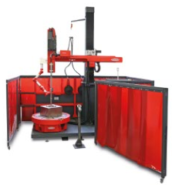
Image 1: The Fronius Compact Cladding Cell consists of perfectly tuned system components: power source set, stand, wirefeeder, rotary table, switch cabinet, controller, and remote control.

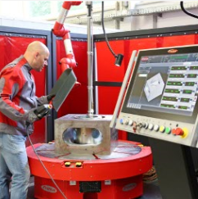
Image 2: The Compact Cladding Cell provides space for components with a diameter of up to 1 m, a height of 1.4 m (extendable to 1.9 m), and a maximum weight of 2,500 kg.

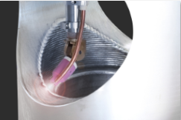
Image 3: Using the TIG hot wire or SpeedClad Twin process, filler material is applied to a part, giving it a protective layer.

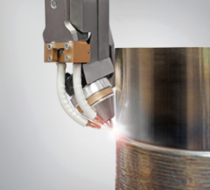
Image 4: SpeedClad Twin achieves three times the speed of the TIG hot wire process with two electrodes and two welding wires.

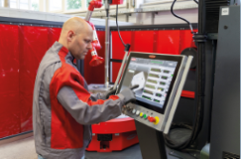
Image 5: The HMI T21 system controls offer 3D real-time visualization and actual value monitoring.

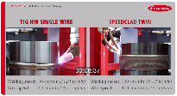
YouTube link: Video of the SpeedClad Twin Process: https://www.youtube.com/watch?v=qD--F1_ZXk4

Copyright to photos: Fronius International GmbH, reproduction free of charge

High-resolution images are available to download at the following link:
www.fronius.com/en/welding-technology/info-centre/press/compact-cladding-cell

Business Unit Perfect Welding
Fronius Perfect Welding is an innovation leader for arc welding and a global market leader for robot-assisted welding. As a systems provider, the Fronius Welding Automation division also implements customized automated complete welding solutions, for the construction of containers or offshore cladding for example. The range is rounded off by power sources for manual applications, welding accessories, and a broad spectrum of services. With more than 1000 sales partners worldwide, Fronius Perfect Welding has great customer proximity.

Fronius International GmbH
Fronius International is an Austrian company with headquarters in Pettenbach and other sites in Wels, Thalheim, Steinhaus and Sattledt. Founded by Günter Fronius in 1945, this long-standing company with a rich tradition will be celebrating its 75th anniversary in 2020. What began as a local one-man venture has grown into a global player with more than 5440 employees worldwide working in the areas of welding technology, photovoltaics and battery charging systems. Its export ratio of around 93 percent is achieved with 34 international Fronius subsidiaries and sales partners/representatives in more than 60 countries. Moreover, its innovative products and services and its portfolio of 1264 registered patents make it an innovation leader on the world market.

For more information, please contact:
Fronius USA LLC, Ms. Welch Stephanie,
6797 Fronius Drive, 46368 Portage, IN
Tel: +1 (219) 734 5701, E-Mail: welch.stephanie@fronius.com

Please send an author's copy to our agent:
a1kommunikation Schweizer GmbH, FAO Kirsten Ludwig,
Oberdorfstraße 31 A, 70794 Filderstadt, Germany,
Tel.: +49 (0)711 9454161-20, e-mail: Kirsten.Ludwig@a1kommunikation.de

For more exciting updates, visit our blog at blog.perfectwelding.fronius.com and follow us on Facebook (froniuswelding), Twitter (froniusintweld), LinkedIn (perfect-welding), Instagram (froniuswelding) and YouTube (froniuswelding)!

